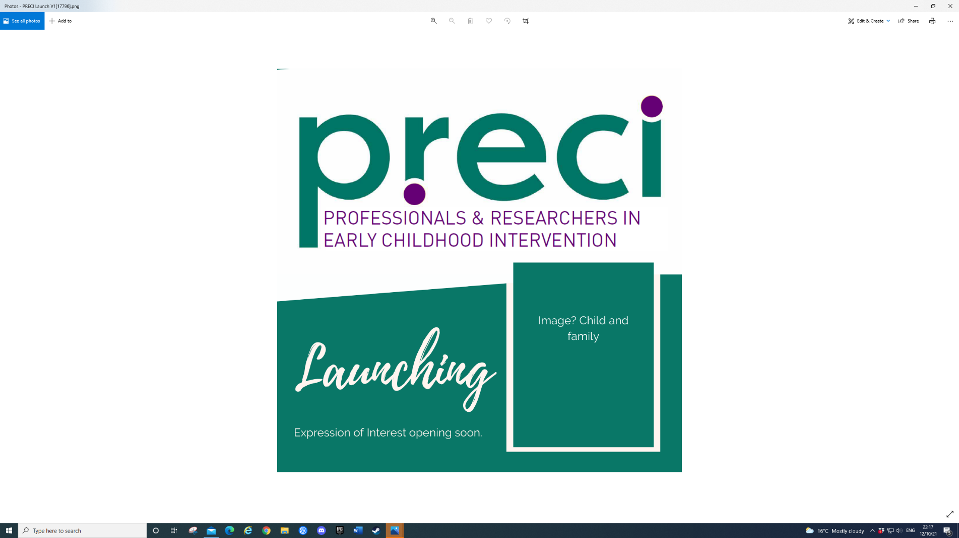



Research Snapshot No. 10

October 2024

Meta-Synthesis of Qualitative Studies: Inclusion in the Early Childhood Years.
Hanline, M. F., Eldridge, J. N., & Robbins, A.

What you need to know

Educating young children with and without disabilities together in inclusive early childhood programs is a critical component of early childhood education (ECE) and early intervention (EI) services.

With potential benefits to all children, the importance of inclusion has been recognised by government departments and professional organisations. For example, a joint position statement in the USA between, the Division of Early Childhood (DEC) of the Council for Exceptional Children (CEC) and the National Association for the Education of Young Children (NAEYC), identified as desired outcomes that all children and their families have “a sense of belonging and membership, positive social relationships and friendships, and development and learning to reach their full potential” (DEC/NAEYC, 2009, p.2).

Reported outcomes of inclusive EC and EI include expanded opportunities for friendship development and chances for children without disabilities to develop empathy, compassion, and a greater understanding of disability. Furthermore, children with and without disabilities are reported to make expected developmental progress in inclusive EC settings.

What is this research about?

This meta-synthesis integrates findings from qualitative research studying the experiences and outcomes of children when they participate in inclusive EC settings. The goal was to promote a broader understanding of practices and outcomes in inclusive EC programs.

A meta-synthesis was chosen as it may provide deeper insights than a single study, adding depth and dimension to the understanding of educational practices and has the potential to identify gaps in a body of research.

To the knowledge of the authors, no meta-synthesis of EC inclusion has previously been conducted.

The researchers sought to answer three research questions:
- How do the qualitative studies ensure methodological rigor by using methods to establish trustworthiness and procedures identified as quality indicators for the methods used to collect data?
- What are the social experiences and outcomes of young students with disabilities and their peers (birth to 8 years of age) who are developing typically when they participate together in general education EC private and public-school settings in the United States?
- What are the learning experiences and outcomes of young students with disabilities and their peers (birth to 8 years of age) who are developing typically when they participate together in general education EC private and public-school settings in the United States?

The goal was to promote a broader understanding of practices and outcomes in
inclusive EC programs.

What did the researchers do?

The researchers used thematic synthesis aims, through systematic coding of data to generate analytical themes. This offers a new interpretation that goes beyond findings of the primary studies included in the meta-synthesis.

This inductive approach involved a three-step process:
- literature search and selection,
- quality appraisal of the primary studies; and
- synthesis of themes within and across primary studies that leads to the development of new descriptive, analytical themes (Tong et al., 2016).

Rigor was evaluated based on the use of procedures
- to establish trustworthiness through credibility, transferability, dependability, and confirmability; and
- identified as quality indicators for the data collection method used.

What did the researchers find?

Eight qualitative studies were included in the meta-synthesis. Evaluation of the studies indicated that they all utilised methods to establish trustworthiness and ensure rigorous methodology for the type of data collected, indicating high-quality of the studies.

As a result of the analysis of these data, three analytic themes were developed.:

- Children with disabilities had opportunities for access to and participation in general education EC classrooms, resulting in children with and without disabilities learning social and developmental/academic skills together.
- Over time, the social interactions between children with and without disabilities resulted in positive relationships among the children and the valuing of the children with disabilities by peers.
- The students with and without disabilities were autonomous in their interactions, taking ownership of the interactions. This autonomy increased over time.

How can you use this research?

The focus of this study on inclusion and its benefits are consistent with ECI service and policy developments in Australia for the last decade. This meta-synthesis provides additional evidence that EC inclusion can result in positive outcomes for children, supporting the call to expand the availability of high-quality inclusion programs. Further, the researchers indicate that the findings highlight the need to understand the timing, type, intensity, and frequency of preservice and professional development that results in EC educators holding positive perspectives of inclusion. This provides us with further guidance on the development of undergraduate and early career support for EC educators and ECI practitioners in an Australian context as well as opportunities for future research.

In 2012, Early Childhood Australia (ECA) and Early Childhood Intervention Australia (ECIA) developed a Position statement on the inclusion of children with a disability in early childhood education and care.

Australia has also developed National Guidelines for Best Practice in ECI (ECIA Vic/Tas, 2016) that has inclusion as one of the four quality areas.

There is currently a national project funded by the Department of Social Services to develop an ECI framework through a consortium led by the University of Melbourne in partnership with Murdoch Children’s Research Institute (MCRI), Professionals and Researchers in Early Childhood Intervention (PRECI), SNAICC - National Voice for our Children, Children and Young People with Disability Australia (CYDA) and the Association for Children with Disability (ACD).

Where to from here?

You can find further information and resources here:

- Early Childhood Australia and Early Childhood Intervention Australia Position statement on the inclusion of children with a disability in early childhood education and care (2012).
https://www.earlychildhoodaustralia.org.au/wp-content/uploads/2014/06/ECA_Position_statement_Disability_Inclusion_web.pdf

- Early Childhood Technical Assistance Centre. Indicators of high-quality inclusion.
https://ectacenter.org/topics/inclusion/indicators.asp

- PRECI
https://www.preci.org.au/

About the researchers

- Dr Hanline: School of Teacher Education, Florida State University, Tallahassee, Florida
- Dr Eldridge: Science Department, Omaha Public Schools, Omaha, Nebraska
- Dr Robbins: Department of Special Education, University of Utah, Salt Lake City, Utah

Citation

Hanline, M. F., Eldridge, J. N., & Robbins, A. (2024). Meta-Synthesis of Qualitative Studies: Inclusion in the Early Childhood Years. Infants & Young Children, 37(4), 294-315.

This Research Snapshot was prepared by Dr Kerry Bull, PRECI committee member and Early Childhood and Early Intervention Consultant.

In the spirit of reconciliation PRECI acknowledges the Traditional Custodians of country throughout Australia and their connections to land, sea and community. We pay our respect to their Elders past and present and extend that respect to all Aboriginal and Torres Strait Islander peoples today.

