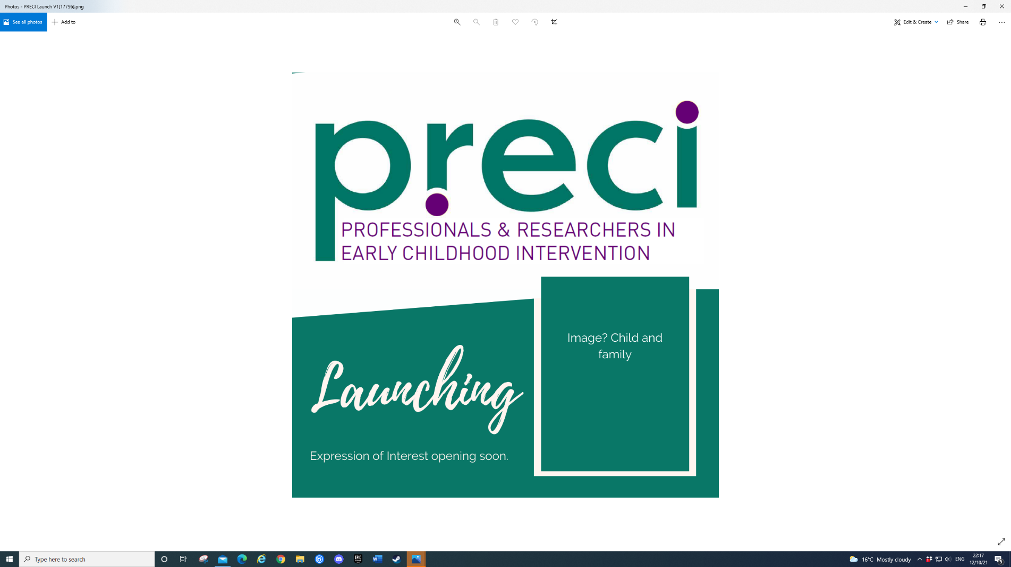


Research Snapshot No. 14

April 2025

Parent Perspectives of Ear Health and the Relationship with Children’s Speech and Language in the Longitudinal Study of Indigenous Children
Anita Morrow and colleagues (2023)

What you need to know

Otitis media (OM) is a common, preventable childhood condition, affecting about 80% of children before the age of three years. However, it is disproportionally more prevalent, long lasting, and acquired earlier and more severe and complicated among Aboriginal and Torres Strait Islander children than non-Indigenous children.

While middle ear disease has long been thought to be associated with poorer speech and language outcomes, recent reviews provide conflicting evidence regarding this relationship. Recent Australian research, that included Aboriginal and Torres Strait Islander children, found that children with OM at age six years had normal language development scores at age six to ten years, other than a small negative relationship between children with bilateral OM at six years and limited receptive vocabulary growth at age 10 years. It is argued that periods of auditory deprivation caused by OM during a critical period of cognitive and language development results in delays in speech and language acquisition.

Using a strengths-based approach, the Footprints in Time: Longitudinal Study of Indigenous Children (LSIC) has been collecting various health data from approximately 1700 Aboriginal and Torres Strait Islander children and their parents in Australia in annual waves since 2008. The study authors are a group of Aboriginal and Torres Strait Islander and non-Indigenous researchers with multidisciplinary expertise and experience across Indigenous health, audiology, speech pathology, paediatrics, and education.

What is this research about?

This study set out to answer the question, what is the relationship between parent-reported ear symptoms and parent-reported concern and their child’s expressive and language skills, and receptive language skills? It was hypothesized that parents who reported no ear symptoms when their child was between two and six years old would be less likely to report concern about their child’s speech and language skills at age five to seven years.

Based on previous research, other variables (covariates) were also investigated to determine if they had an impact on child speech and language outcomes. They included sex of the child, remoteness, socio-economic status, if the child was ever breastfed, parental smoking status, maternal education, source of income, number of children in household, number of people on household, and child’s disability type if present.

What did the researchers do?

A total of 787 children were selected using a two-stage purposive sampling from 11 communities across Australia, varying in levels of remoteness. The design used was a quantitative longitudinal cohort using waves one to five of LSIC. Parent reported of ear symptoms (“runny ears”) was used as the predictor variable, whereas parent-reported expressive and receptive speech language concerns were the outcome variables. The latter were measured using questions from the Parents’ Evaluation of Developmental Status (PEDS).

The ear health information of children was collected at two time points: when they were approximately two to four years old and then approximately four to 6 years old. The two speech and language outcomes were measured approximately one year later at around five to seven years old.

Data analysis was conducted using SPSS statistical software. First, LSIC waves were combined to create the accumulative ear health predictor variable and to reflect data representative of the same participants at the different time points. Second, Chi-square tests were performed of the predictor and outcome variables, and of the covariates and the outcome variables. Third, two binary logistic regression models were utilised to investigate relationships between parent-reported ear symptoms and parent-reported expressive and receptive language concerns, after adjusting for all other covariates.

LSIC obtained approval from the Australian Institute of Aboriginal and Torres Strait Islander Studies (AIATSIS) Ethics Committee. State and territory and/or regional ethical approval has been obtained for all study sites through state and territory Human Research Ethics Committees or their equivalents. Parents provided consent to participate in the study at the beginning of 2008.

What did the researchers find?

- 82.6% of parents reported no ear symptoms and concern about their child’s expressive speech and language while 95.4% parents reported no ear symptoms and no concern about their child’s receptive language.
- 17.4 % of parents reported their children had no ear symptoms but reported concerns about their child’s expressive speech and language; 4.6% parents reported their children had no ear symptoms but reported concerns about their child’s receptive language.
- A strong relationship was found between Aboriginal and Torres Strait Islander children’s parent-reported ear health in the early years of life and parents’ perceptions of their speech and language skills one year later.
- Parents who reported their child experienced no ear symptoms in two consecutive years (aged between two and five years), reported lower concern for their child’s expressive and receptive speech and language (aged between five and six years).
- The relationship between parent-reported ear health and expressive speech and language was present after adjusting for the covariates of sex, remoteness, socioeconomic status, and the child’s overall (global) health and (non-speech) disability.
- The relationship between parent-reported ear health and receptive language was present after adjusting for the covariate (non-speech) disability.
- Ear symptoms were a stronger predictor of receptive language concern than for expressive speech and language concern, although the pro-portion of parents reporting receptive language concern was lower than for expressive speech and language concern.
- There was a lower prevalence of concern in remote living families, which may reflect cultural diversity in remote areas and the relevance of the PEDS as a measure.

How can you use this research?

This study highlights the importance of the links between health concerns such as OM on Aboriginal and Torres Strait Islander children’s expressive and receptive language outcomes. It increases our understanding of how OM symptoms may lead to hearing loss and have an impact on cognitive development, and children’s speech and language.

The study findings have implications about how to work with young Aboriginal and Torres Strait Islander children; practitioners need to consider cultural and linguistic diversity as well as cultural safety in all aspects of speech and language measures (i.e., interviews, standardised measures), programs and interventions. Furthermore, effective support for Aboriginal and Torres Strait Islander children and their families require services to be family-centred and strengths-based across health and speech and languages supports.

The National Best Practice Framework for Early Childhood Intervention currently underway has cultural safety for Aboriginal and Torres Strait Islander children and families as one of its key principles. It highlights the need to have practices and assessments supporting children’s strengths and identities.

Where to from here

Resources
- Footprints in Time: The Longitudinal Study of Indigenous Children. Retrieved from https://www.dss.gov.au/long-term-research/footprints-time-longitudinal-study-indigenous-children
The National Agreement on Closing the Gap. Retrieved from https://www.closingthegap.gov.au/national-agreement

National Aboriginal and Torres Strait Islander Early Childhood Strategy. Retrieved from https://www.niaa.gov.au/resource-centre/national-aboriginal-and-torres-strait-islander-early-childhood-strategy

The Early Years Strategy 2024-2034. Retrieved from https://www.dss.gov.au/early-years-strategy/resource/early-years-strategy-2024-2034

D’Aprano, A., Silburn, S., Johnston, V., Robinson, G., Oberklaid, F., & Squires, J. (2016). Adaptation of the ages and stages questionnaire for remote aboriginal Australia. Qualitative health research, 26(5), 613-625. Retrieved from https://onlinelibrary.wiley.com/doi/abs/10.1111/j.1440-1754.2010.01883.x

PRECI. National Best Practice Framework for Early Childhood Intervention: Updates. Retrieved from https://www.preci.org.au/bp-framework-eci/

About the researchers

- Anita Morrow, Neil Orr, Kai Nash, Cara Cross, Andrea Salins, Catherine McMahon: Department of Linguistics, Faculty of Medicine, Health and Human Sciences, Macquarie University Hearing, Macquarie University
- Harvey Coates: School of Medicine, The University of Western Australia
- John Robert Evans: Moondani Toombadool Centre, Swinburne University of Technology
- Hasantha Gunasekera: Children’s Hospital Westmead Clinical School, The University of Sydney
- Samantha Harkus: National Acoustic Laboratories, Macquarie University
- Linda Harrison: Macquarie School of Education, Macquarie University
- Sharynne McLeod: Charles Sturt University
- Katie Neal: Department of Linguistics, Faculty of Medicine, Health and Human Sciences, Macquarie University Hearing; The Shepherd Centre
- Rona Macniven: Department of Linguistics, Faculty of Medicine, Health and Human Sciences, Macquarie University Hearing; School of Population Health, Faculty of Medicine & Health, UNSW

Citation
Morrow, A., Orr, N., Nash, K., Coates, H., Cross, C., Evans, J. R., Gunasekera, H., Harkus, S., Harrison, L., McLeod, S., McMahon, C., Neal, K., Salins, A., & Macniven, R. (2023). Parent perspectives of ear health and the relationship with Children’s speech and language in the longitudinal study of indigenous children. Children, 10(1), 165.

This Research Snapshot was prepared by Dr. Susana Gavidia-Payne, Associate Professor (RMIT University), PRECI Board member.
In the spirit of reconciliation PRECI acknowledges the Traditional Custodians of country throughout Australia and their connections to land, sea and community. We pay our respect to their Elders past and present and extend that respect to all Aboriginal and Torres Strait Islander peoples today.

